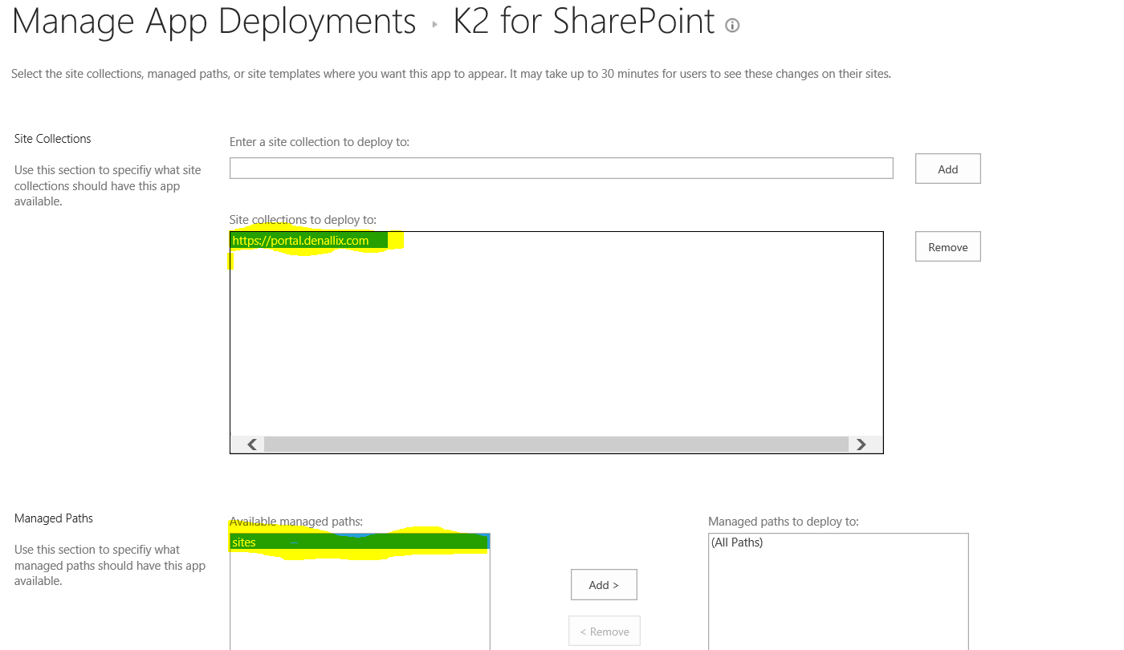
- Remove everything highlighted in yellow than at the bottom of the page click OK.
- If you get this prompt (as below) just click on Trust It.
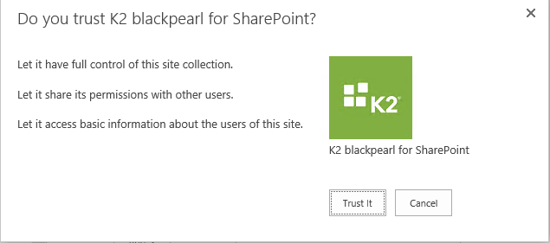
- Then only add back the items circled in red like below than at the bottom of the page click OK.
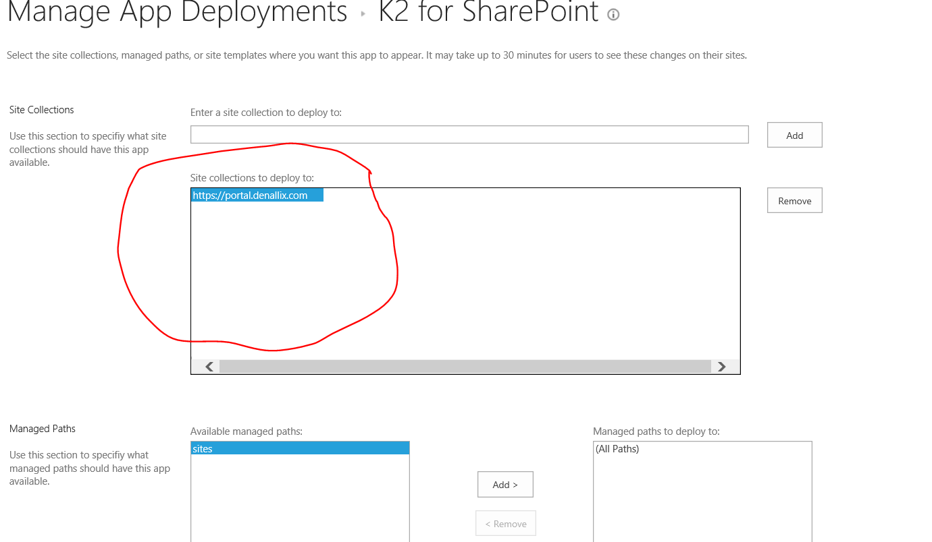
- If you get this prompt (as below) just click on Trust It.

